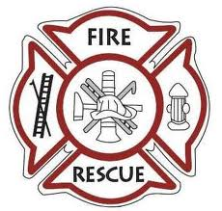

Dear applicant,
We welcome your membership application to join the Macedon Center Volunteer Fire Department. The attached application process guide will provide you with detailed instructions on how the application process works and what steps that you will need to take in order to complete the application process. It is important that you fill out each part of the application packet completely and honestly.
As I am sure you will agree, our organization is one in which integrity is paramount. Our reputation is directly related to the code of conduct displayed by each of our members. Our members deal directly with the public and it is important that they be concerned for the safety and welfare of the public at all times. Therefore, please be aware that we will thoroughly scrutinize the information that you provide on the membership application. We do this in an effort to provide the citizens of our community with individuals who will uphold the excellent reputation of the Macedon Center Volunteer Fire Department.
Thank you for your interest and, hopefully, you can become a valuable part of our organization.
Sincerely,
Macedon Center Fire Department membership committee.

